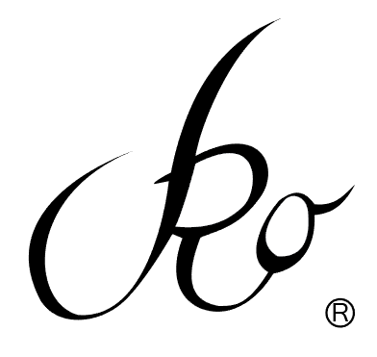Engineered Designs, LLC
Labor Cost Breakdown Request Form
Use this form to request the approximate cost of your project. Please include the following:
Company Name |  | Physical address | Phone & Fax | website | Facebook
Owner #1 | Name | mobile | Email address
Owner #2 | Name | mobile | Email address
Owner #3 | Name | mobile | Email address
Project Type | Description | # of styles
*Style # | Description | Fashion sample needed | Budget range |  | Due date
- fabric | Yes/no
- trim | Yes/no
*Style # | Description | Fashion sample needed | Budget range |  | Due date
- fabric
- trim
*Style# | Description | Fashion sample needed | Budget range |  | Due date
- fabric
- trim
Start date |  | Midpoint Check |  | Finish date
Depending on the number of projects ahead of your request, the LCB may take up to 3 weeks to prepare and send, however, most are completed within 10 days.
There is no additional cost for preparing a Labor Cost Breakdown unless you need a rush. The rush fee is $10. If you have scheduled and paid for a consultation of 1 hour or more, the cost for preparing the LCB is included. If you have not scheduled a consultation, or only requested a 30 minute session, the cost to prepare the document is $25. Please be advised that initial in-person consultations or actual samples mailed help to better determine the costs.
*If you have not assigned style number(s) to your project, a style number will be created for you. You may change this number at any time during the product development process, however, if patterns have been printed with the old number, you will be charged for the reprint. Please see the costs for printing in the pattern paper prices section.
Please send this document to vfavors@vroengine.com or mail to
VRO Engineered Designs, LLC
1775 Parker road, suite C-210
Conyers, GA 30094
678-487-3700
Other pertinent information:
____________________________________________________________________________________________________________________________________________________________________________________________________________________________________________________________________________________________________________________________________________________________________________________________________________________________________________________________________________________________________________________________________________________________________________________________________________________________________________________________________________________________________________________________________________________________________________________________________________________________________________________________________________________________________________________________________________________________________________________________________________________________________________________________________________________________________________________________________________________________________________________________________________________________________________________________________________________________________________________________________________________________________________________________________________________________________________________________________________________________________________________________________________________________________________________________________________________________________________________________________________________________________________________________________________________________________

Artwork if applicable:

